
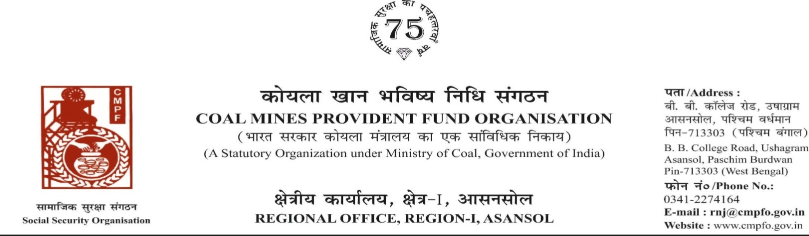
CPF/118/Misc/Ext-out/R-I/ASN/ Dated-27/06/2025

To,
The regional Commissioner
CMPFO,SBP
P.O.-Jagrutivihar, Dist.-Sambalpur
State - Odisha, PIN- 768020

Sub- Supply of Extract of "VV" statement

Sir,

On the subject and reference cited above, enclosed please find herewith the extract in r/o-
Sri Kishore Ram Ratan CMPF A/C No- BBSR/23/30 as required. Ledger Card is not available in this region.

Encl- As above

Yours faithfully

Assistant Commissioner

